**Machine learning‐enabled biomimetic electronic olfaction using graphene single-channel sensors**

**Gianaurelio Cuniberti**1, 2, 3, Shirong Huang1, Alexander Croy4, Bergoi Ibarlucea1, 2

1. Institute for Materials Science and Max Bergmann Center for Biomaterials, TU Dresden, 01062 Dresden, Germany
2. Center for Advancing Electronics Dresden (cfAED), TU Dresden, 01062 Dresden, Germany
3. Dresden Center for Computational Materials Science (DCMS), TU Dresden, 01062 Dresden, Germany
4. Institute for Physical Chemistry, Friedrich Schiller University Jena, Helmholtzweg 4, 07743, Jena, Germany

**Email: gianaurelio.cuniberti@tu-dresden.de**

Olfaction is an evolutionary old sensory system, which provides sophisticated access to information about our surroundings. 1 Inspired by the biological example, electronic noses (e-noses) in combination with efficient machine learning techniques aim to achieve similar performance and thus to digitize the sense of smell. 2, 3 Despite the significant progress of e-noses, their compactness still remains challenging due to the complex layout design of sensor arrays with a multitude of receptor types or sensor materials, and the high working temperature. 4 Here we present the discriminative recognition of odors using graphene single-channel nanosensor based electronic olfaction in conjunction with machine learning. The developed prototype exhibits excellent odor discrimination and identification performance at room temperature, as shown in Figure 1, maximizing the obtained results from a single nanosensor. Upon exposure to binary odor mixture, the response features behave similarly to existing individual odor component, mimicking the overshadowing effect in human olfactory perception. The developed platform may facilitate miniaturization of e-noses, digitization of odors, and distinction of volatile organic compounds (VOCs) in various emerging applications.

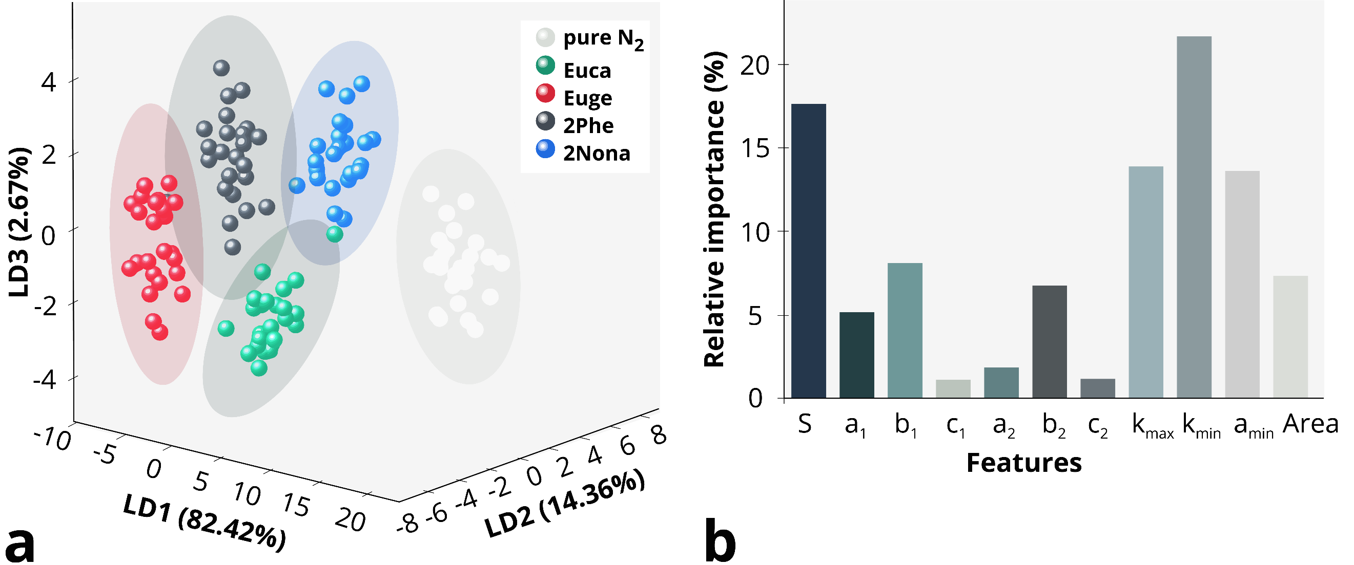

**Figure 1 Odor identification performance of the e-olfaction platform.** **(a)** Odor classification results by Linear Discriminant Analysis (LDA) classifier algorithm in 3D space (LD1 *vs* LD2 *vs* LD3). **(b)** Relative importance loading of 11 features on the odors identification implementing with Random Forest algorithm.

**Reference**

1. Sarafoleanu, C.et.al. J Med Life 2009, 2 (2), 196-8.
2. Gardner, J. W.et.al. Sensors and Actuators B: Chemical 1994, 18 (1-3), 210-211.
3. Covington, J. A.et.al. IEEE Sensors Journal 2021, 1-1.
4. Kumar, R.et.al. Nano-Micro Letters 2020, 12 (1).